**Whitewater Rafting Website Plan**

**Logo Selection**

**Logo Image**: 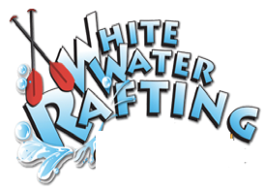

**Color Palette**

1. **Primary Color**: #00001E
2. **Secondary Color**: #6CC2EB
3. **Accent1 Color**: #733634
4. **Accent2 Color**: #D7EDF8

**Typography Selection**

1. **Heading Font**: "Oswald", sans-serif
2. **Text Font**: "Lato", sans-serif

**Coolors.co URL**

<https://coolors.co/palette/00001e-6cc2eb-733634-d7edf8-4f829a>